<https://interview.brainmeasures.com/Assessment>

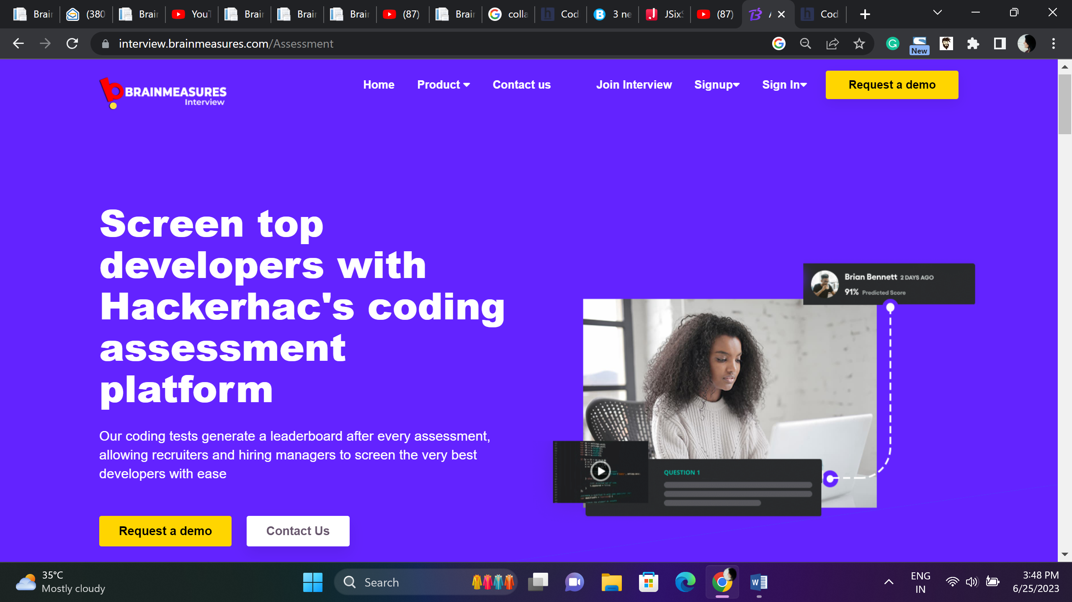

Choose Brainmeasures Code Assess Platform and Hire Top Developers across Globe

Our coding tests generate a leaderboard after every assessment, allowing recruiters and hiring managers to screen the very best developers with ease

Code Assess platform developed using AI and ML allows hiring managers to recruit and retain candidates with perfect job fit and an asset to the organization.

Request Demo Contact US

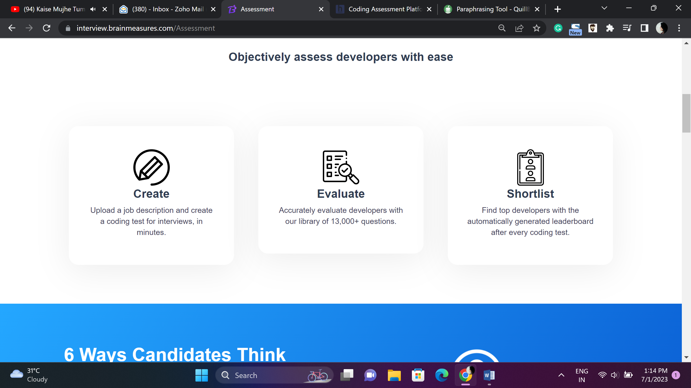

**Hire and Retain the Best**

**Choose Brainmeasures for effortless but Efficient Hiring drives**

**Create**

Just click few buttons and get your interview test ready in minutes, upload job description and create tests.

Quick and Smart Testing

**Assess**

Choose best developers, Brainmeasures has a library of 15K plus questions developed to access talent and practical knowledge, hiring cannot go wrong when using Brainmeasures.

**Shortlist**

Choose best developers and build your talent pool, after every code testing drive the leaderboard gets updated helping you choose top performers based on pre-selected parameters.

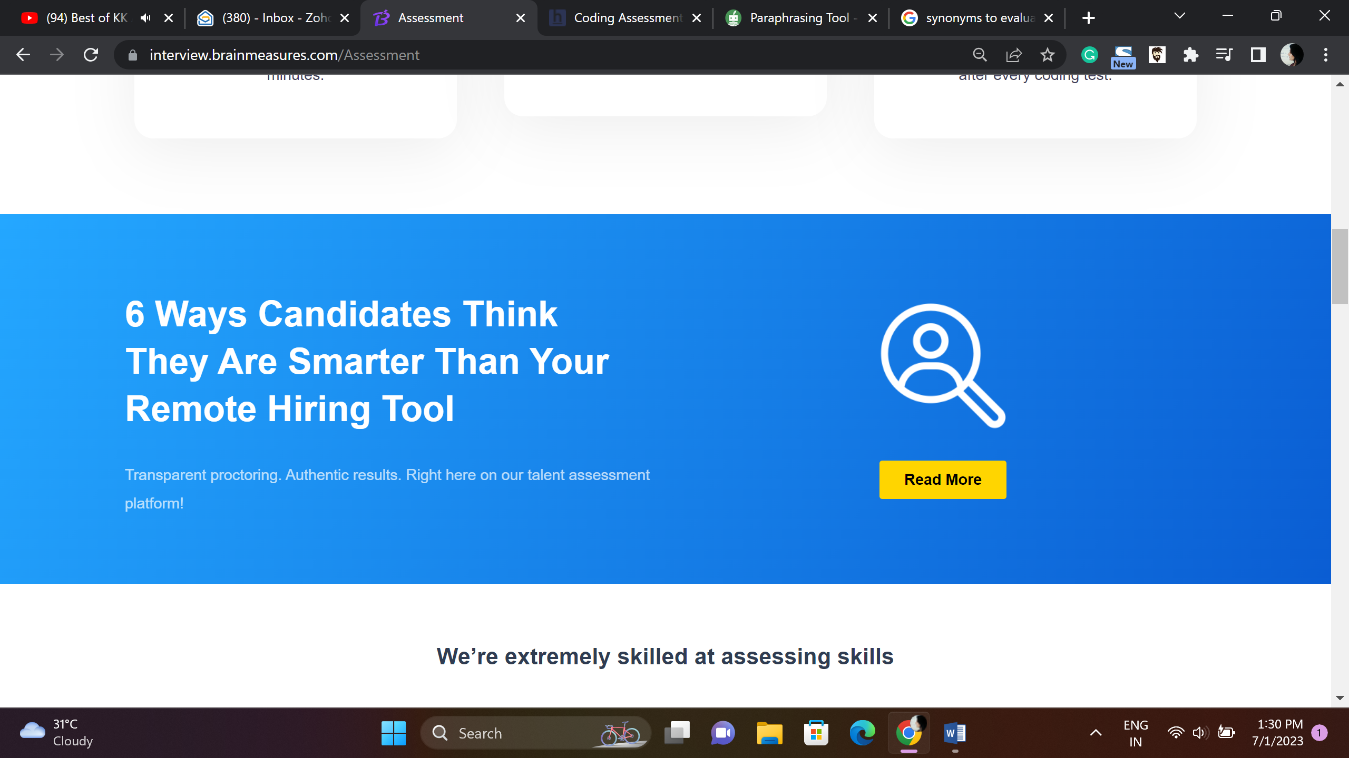

Remote Hiring Tools – Can candidates outsmart Brainmeasures?

Technologically advance proctoring solution build by experts to choose experts.

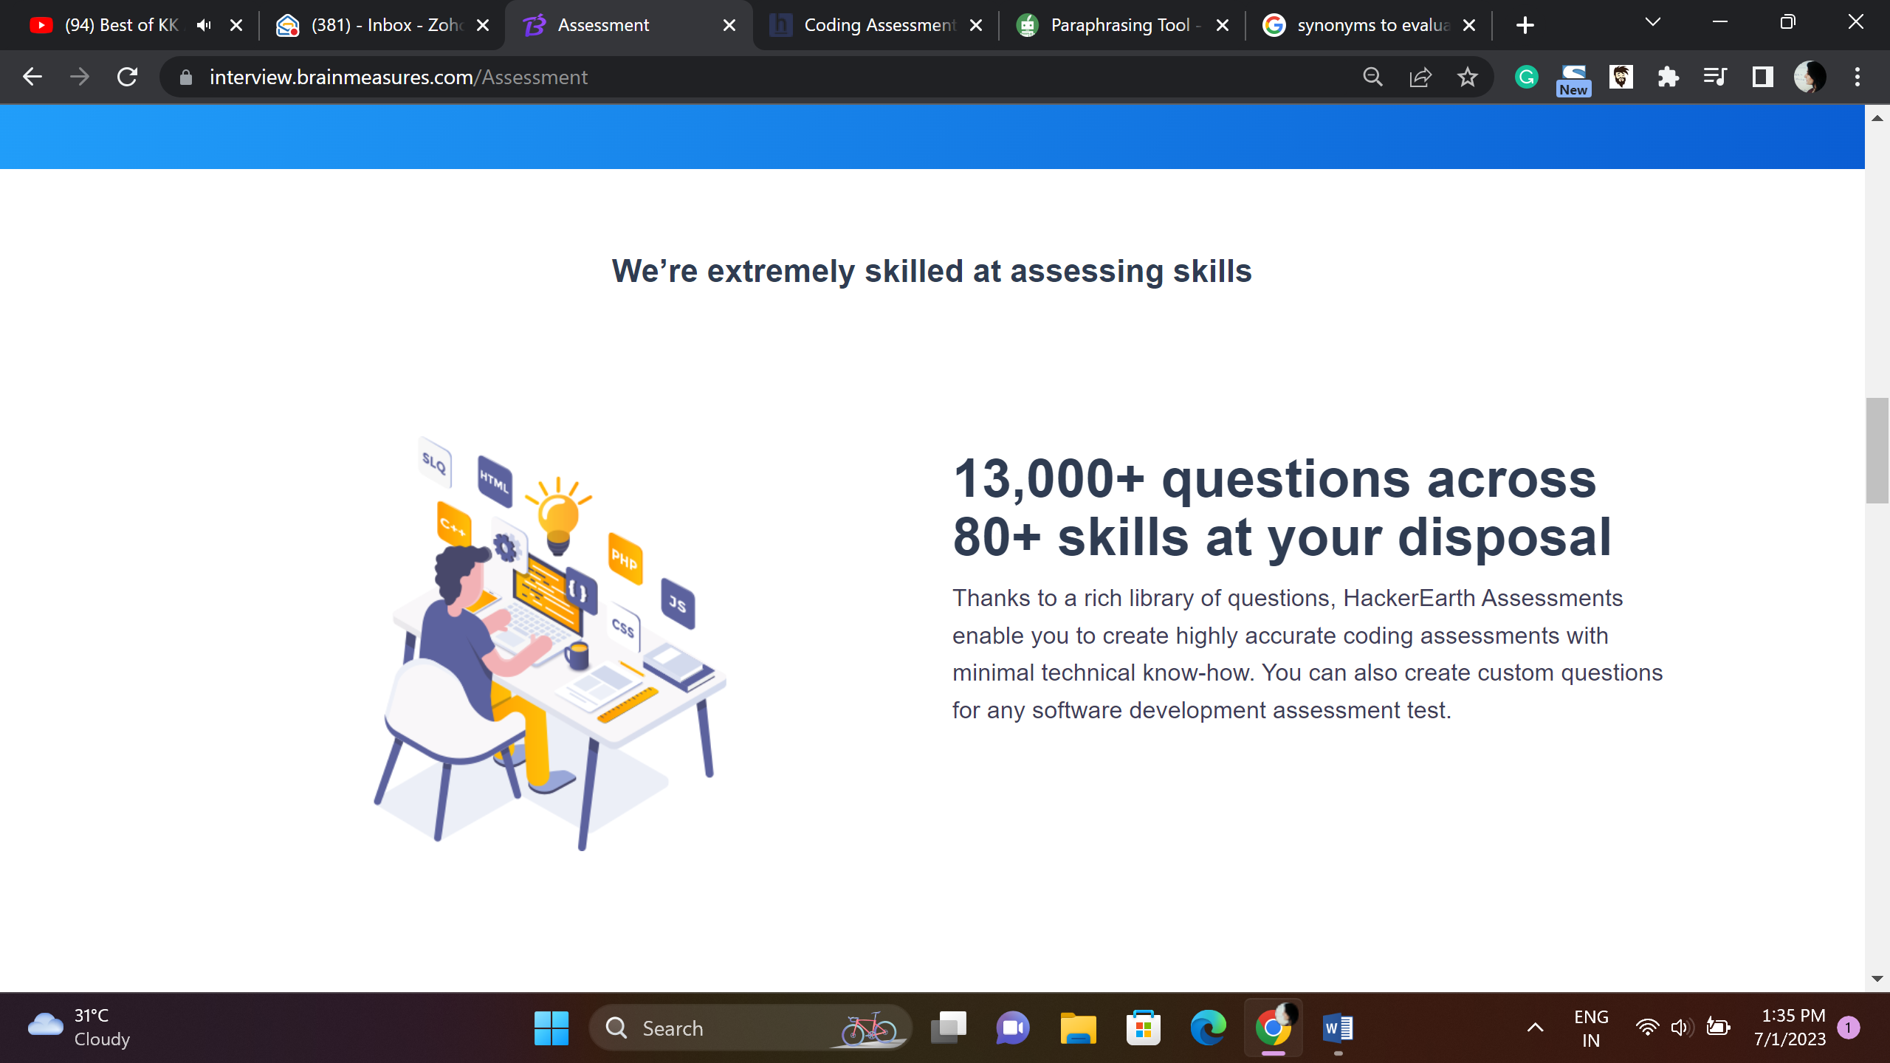

**Assess Skill and Choose the Best**

**Reservoir of 15K + Questions based on multitude skills, build skill tests that assess real talent.**

Brainmeasures question library is developed by subject matter experts and working professionals who understand what a candidate needs to know to deliver desired output.

If you want to use your questions for testing you can do that and we also offer customized services if you want to create tests to match your specific needs.

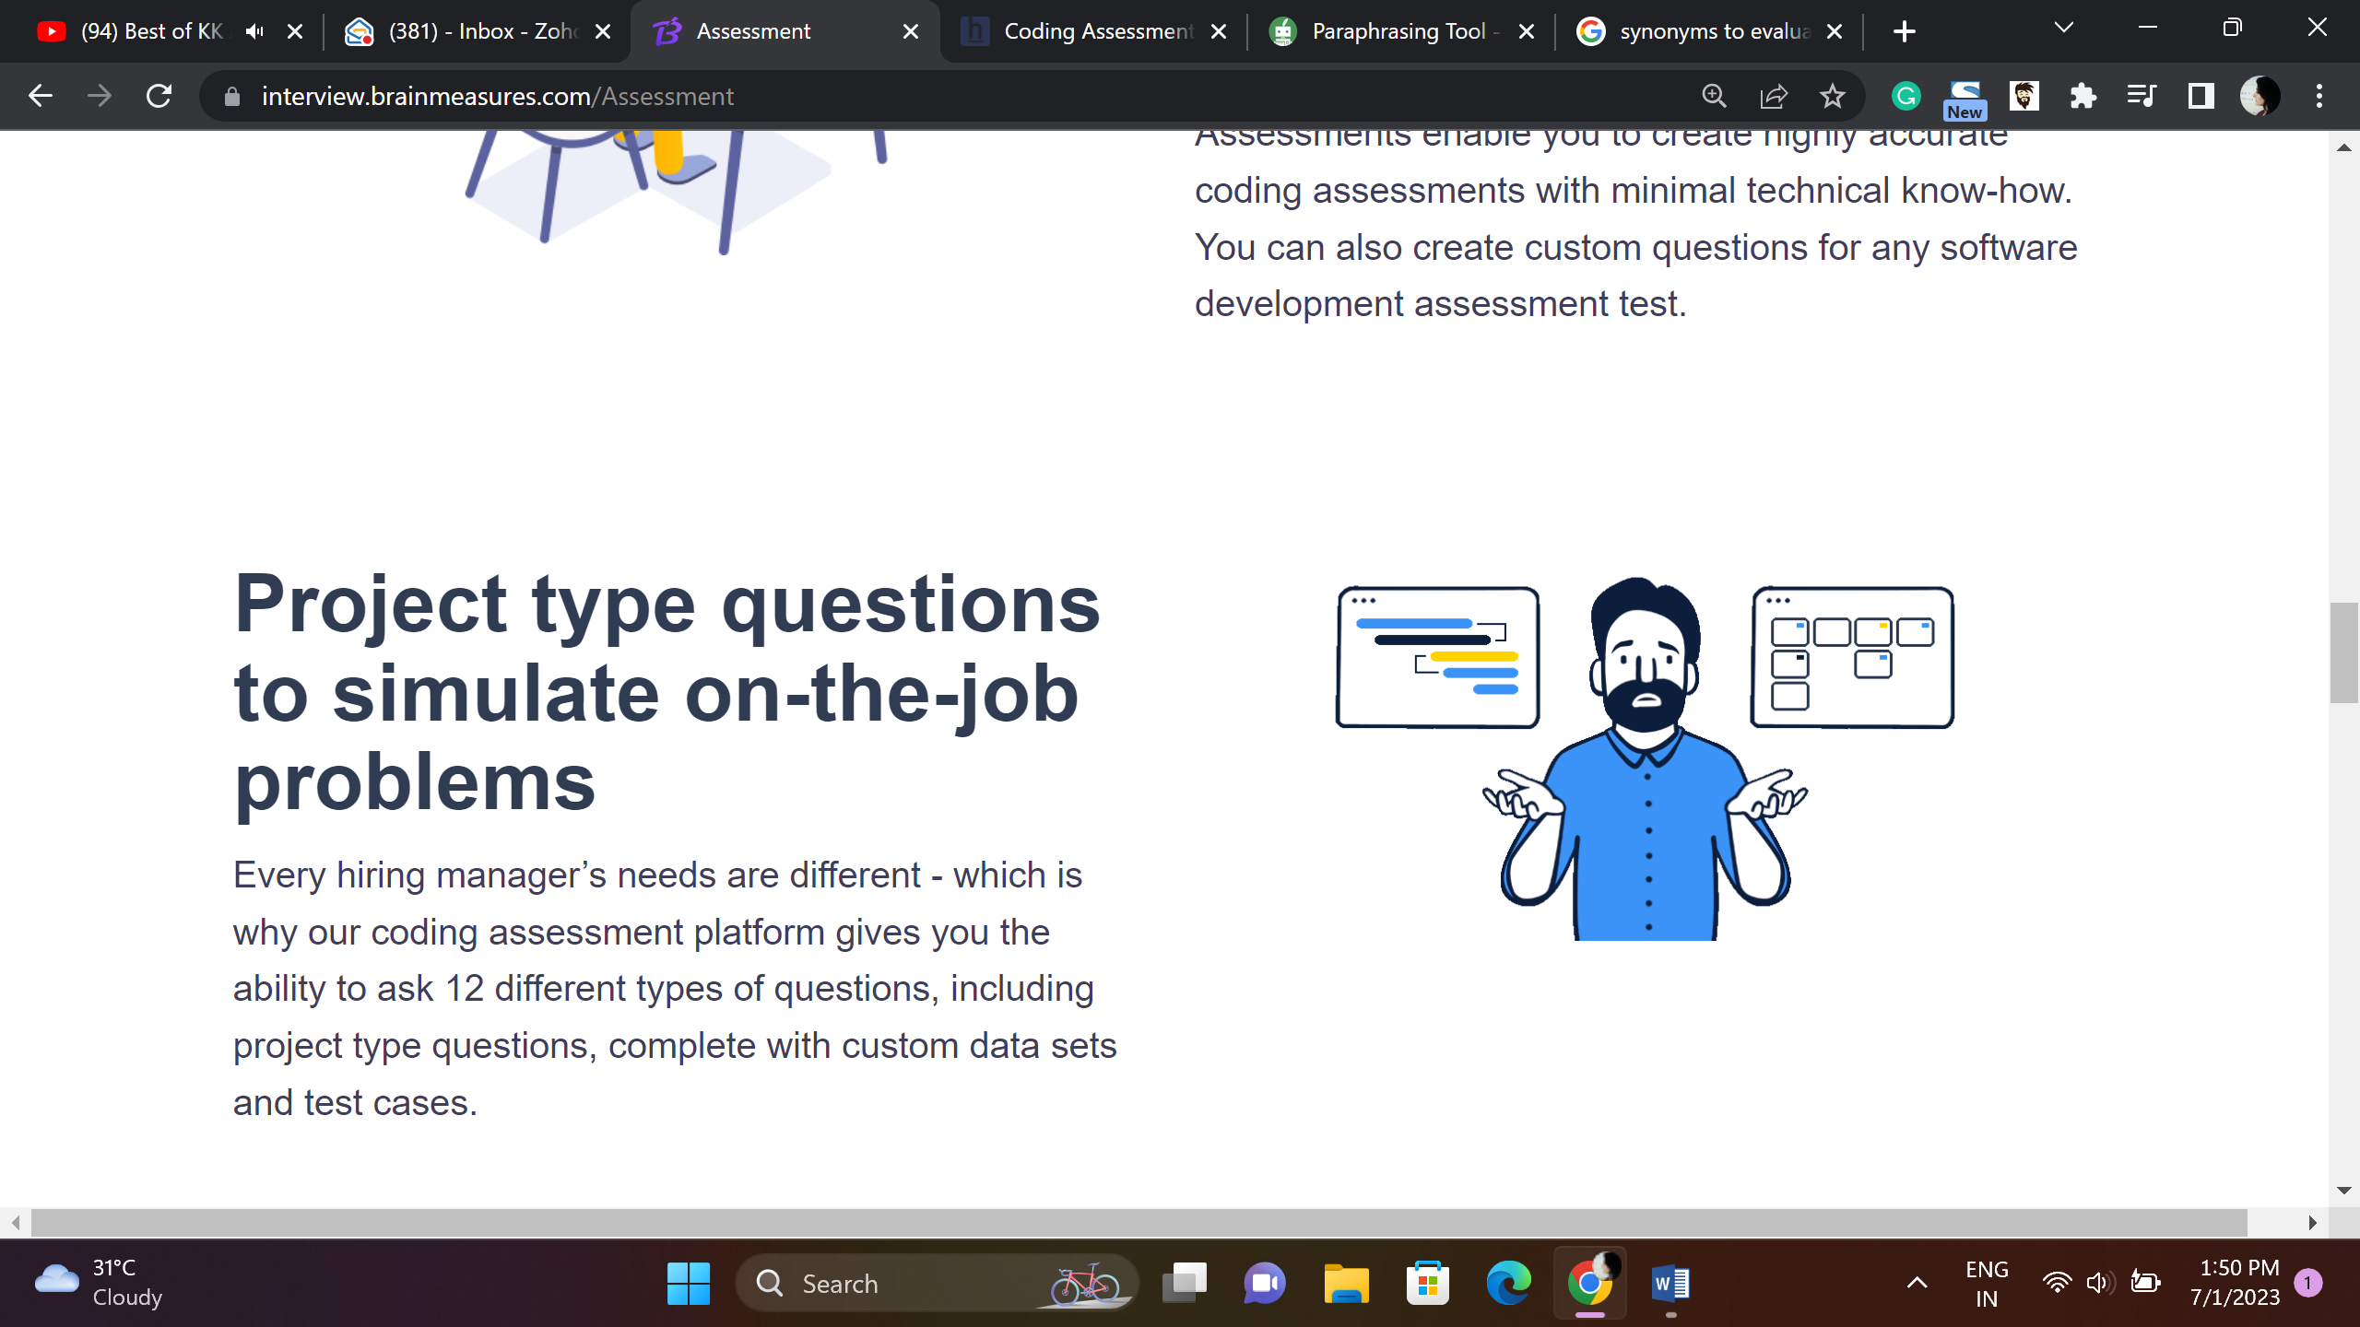

Project Type Questions

We understand different hiring managers have different approach, we provide 14 different type of questions, customize and create tests to choose desired talent.

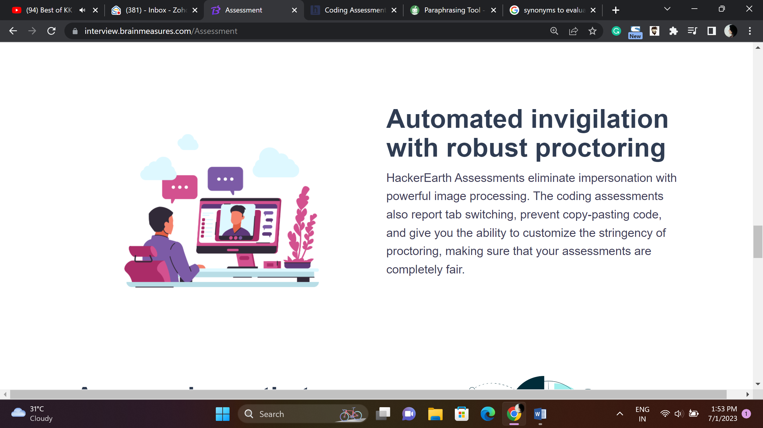

**Advance Proctoring System**

Brainmeasures advance proctoring system ensures that candidates don’t use any kind of malpractice, with features like face and voice detection, tab-switching alert, deactivated copy paste feature and many other features ensures fair assessment.

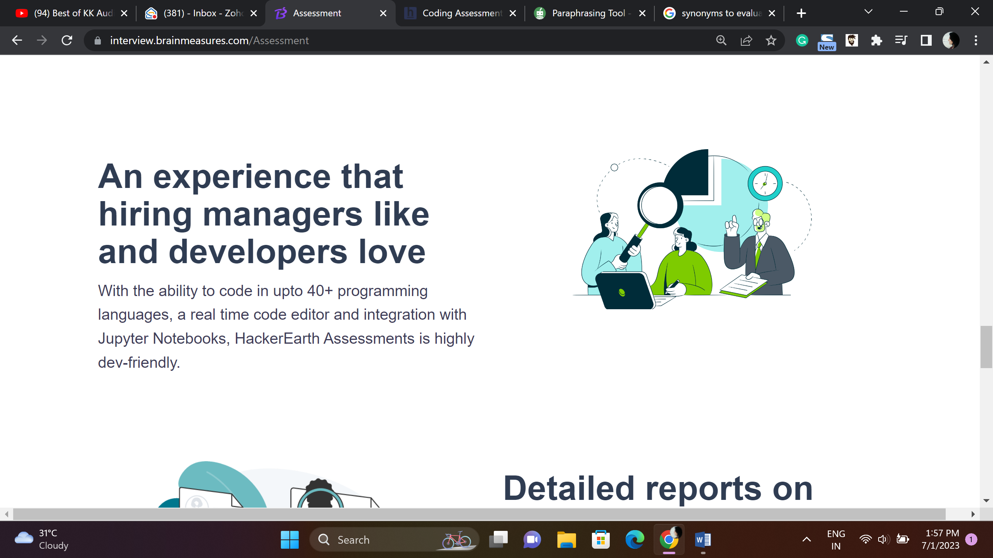

Dev-Friendly Assessments

Brainmeasures assessment platform provides seamless and smooth experience to both hiring managers and developers, code in 50 + languages, real time code editor and many other advanced features make Brainmeasures assessment platform incredibly attractive.

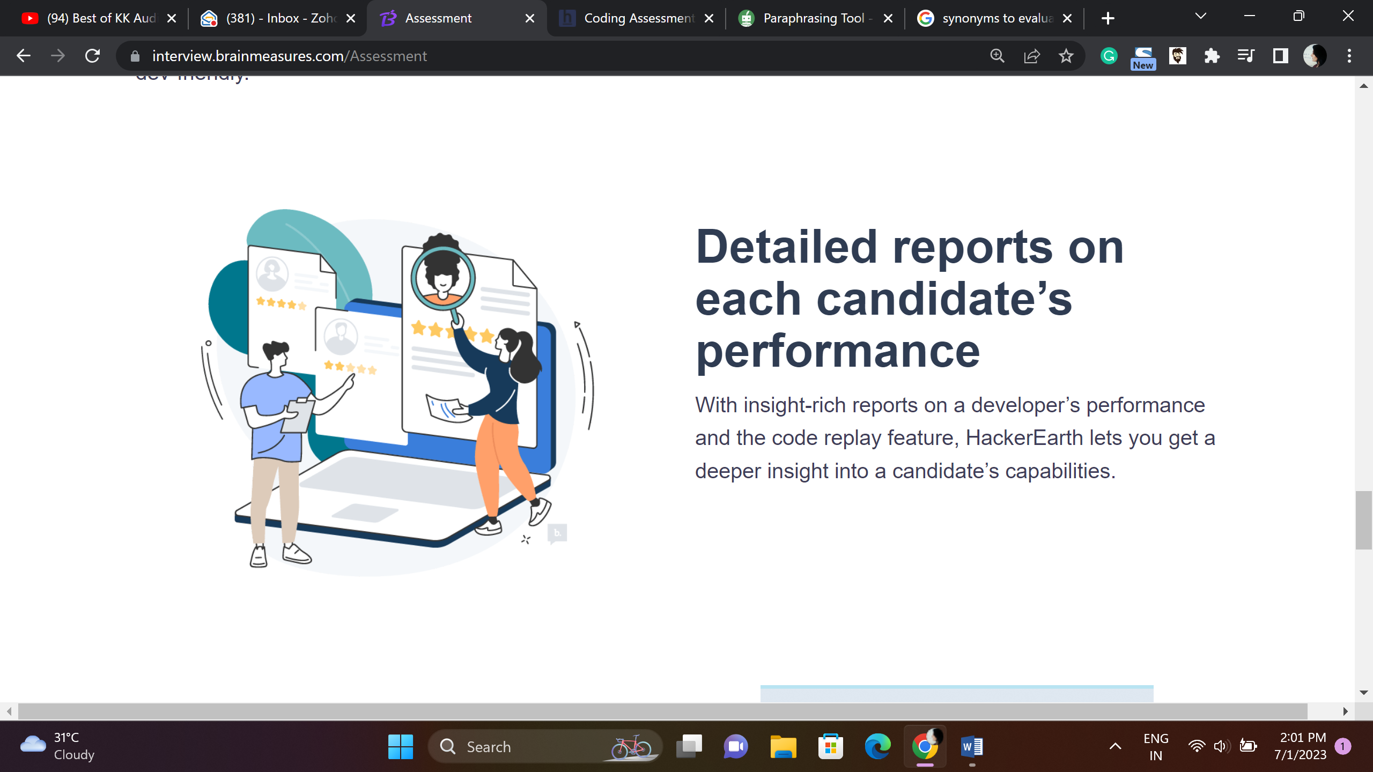

**Detailed Analytic Reports**

Brainmeasures makes the hiring process hassle free, after each assessment the system generates detailed result report for each candidate, highlighting the strengths and qualities candidates need to perform at their job. These repots make the hiring process easy for recruiters.

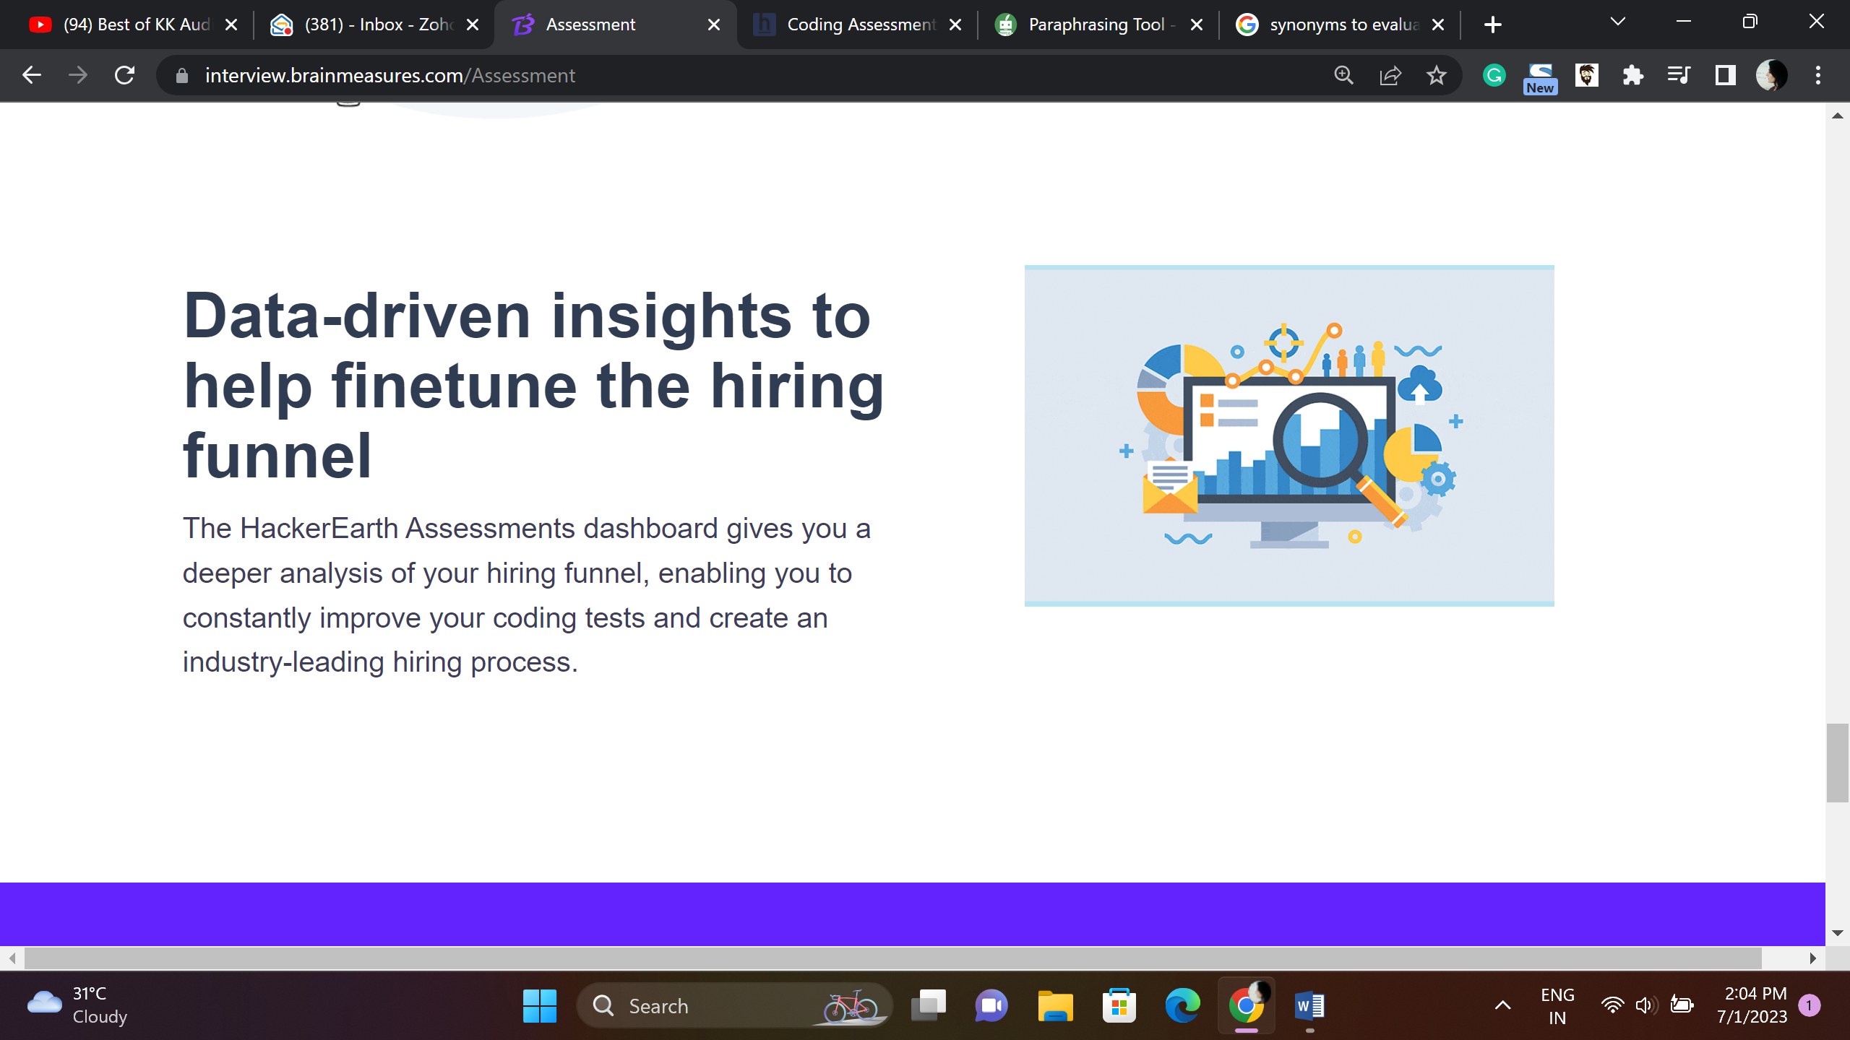

**Data driven analytics Reports**

Analyze your hiring funnel and refine it constantly using data driven analytic reports generated by Brainmeasures to develop a robust hiring process for your organization.

